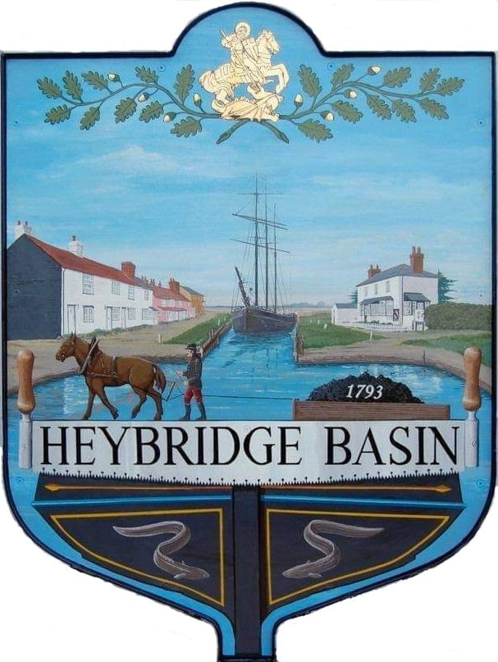

HEYBRIDGE BASIN PARISH COUNCIL

Minutes of the Extraordinary meeting of Heybridge Basin Parish Council held on Monday 29th April 2024 at 06:30pm, at The Lock Tearoom.

PRESENT

In the Chair: M. Hodges (Chair) Absent: 0

Councillors: R. Bryson (Vice Chair) Apologies: 2
C. Swann
G. Howat Public: 4
J. Sjollema
Officers: G. Lake – Clerk

It was noted that this meeting was being recorded by the Clerk.

23/252 Chair’s Welcome
Cllr Hodges welcomed everyone to the meeting and explained that this meeting was called due to the number of items that were due to be on the April Agenda.

23/253 Apologies for Absence.
Cllrs Edmond and Hobden.

23/254 To receive Declarations of Interest in accordance with the Council’s Code of Conduct and with section 106 of the Local Government Finance Act 1992.
Cllr Swann - Non-Pecuniary -Owner of Tearoom building and Cllr Howat – Non-Pecuniary - HBCSA

23/255 Finance.
- To approve
- Accounts for the nine months to 31st December 2023.
The accounts as previously circulated were approved.
- Accounts for the twelve months to 31st March 2024.
The accounts as previously circulated were approved.

23/256 D-Day 80
  - To receive an update from the Working Group and agree any action to be taken.
An update was received. A representative of Save Maldon’s Medical Service’s gave an update on their fundraising campaign to raise funds for legal fees. It was resolved that Save Maldon’s Medical Services would have a tombola/plant stall at the D-Day event. It was resolved to purchase 2 gas cylinders at a cost of £105.00 each. It was resolved to invite Carole Lawson to light the beacon and for the Clerk to send a formal invitation.

1 member of public left.

23/257 St Georges Pedestrian Sign
  - To receive an update from Cllrs Hodges and Howat and agree any action to be taken.
It was resolved that Cllr Hodges would contact Adey for costs of a wooden sign.

23/258 Pursuant to section 1(2) of the Public Bodies (Admission to Meetings) Act 1960 it is resolved that, in view of the confidential nature of the business about to be transacted, it is advisable in the public interest that the press and the public be excluded, and they are instructed to withdraw.

3 representatives of Govey Homes Ltd stayed to discuss the next item.

23/259 Timber Yard
  - To discuss the proposal received from Govey Homes Ltd and agree any action to be taken.
A discussion was held regarding the proposal. It was resolved for Govey Homes Ltd to e-mail Clerk the proposed plans for the Council to review and to organise an EGM if required.

The 3 representatives of Govey Homes Ltd left.

23/260 URC
  - To receive an update from the Clerk and agree any action to be taken.
An update was received. It was resolved for Cllr Howat to draft a response to the owners of the building.

23/270 DMCP
  - To discuss correspondence received from Bargemaster ‘s Cabin and agree any action to be taken.
It was resolved to issue permits costing £20 per month per staff member vehicle and for the Clerk to prepare the application form and send it to the owners.

There being no further business the meeting closed at 08:01pm
Provisional Date of the next Council Meeting Monday 20th May 2024

Clerk Contact details: clerk@heybridgebasinpc.org.uk
Website: www.heybridgebasin-pc.gov.uk

